**MOVIE RECOMMENDATION SYSTEM**

Submitted in partial fulfillment of the requirements

of the degree of

Bachelor of Engineering in

Information Technology

by

**NANDANA ANILKUMAR NAIR (D15B-48)**

**PRAJWAL VIJAY PATIL (D15B-52)**

**SAKSHI SANTOSH PATIL (D15B-53)**

under the guidance of

Supervisor (s):

**Mrs. Bincy Ivin**



**Department of Information Technology**

**Vivekanand Education Society’s Institute of Technology**

**2022-2023**

**Department of Information Technology**

**CERTIFICATE**

This is to certify that **Ms. NANDANA ANILKUMAR NAIR(48), Mr. PRAJWAL VIJAY PATIL(52), Ms. SAKSHI SANTOSH PATIL(53)** of Second Year Information Technology studying under the University of Mumbai have satisfactorily presented the Mini Project entitled **MOVIE RECOMMENDATION SYSTEM** as a part of the MINI-PROJECT for Semester-VI under the guidance of **Mrs. BINCY IVIN** in the year 2022-2023.

Date:

(Name and sign) (Name and sign)

Head of Department Supervisor/Guide

**Department of Information Technology**

**DECLARATION**

We, **NANDANA NAIR (48), PRAJWAL PATIL (52), SAKSHI PATIL (53)** from **class D15B**, declare that this project represents our ideas in our own words without plagiarism and wherever others' ideas or words have been included, we have adequately cited and referenced the original sources.

We also declare that we have adhered to all principles of academic honesty and integrity and have not misrepresented or fabricated or falsified any idea/data/fact/source in our project work.

We declare that we have maintained a minimum 75% attendance, as per the University of Mumbai norms.

We understand that any violation of the above will be cause for disciplinary action by the Institute.

Yours Faithfully

1. NANDANA NAIR

2. PRAJWAL PATIL

3. SAKSHI PATIL

**Acknowledgment**

We are thankful to our college Vivekanand Education Society’s Institute of Technology for considering our project and extending help at all stages needed during our work of collecting information regarding the project.

It gives us immense pleasure to express our deep and sincere gratitude to Assistant Professor **Mrs. Bincy Ivin** for her kind help and valuable advice during the development of the project synopsis and for her guidance and suggestions.

We are deeply indebted to the Head of the Information Technology Department **Dr.(Mrs.) Shalu Chopra** and our Principal **Dr. (Mrs.) J.M. Nair** for giving us this valuable opportunity to do this project.

We express our hearty thanks to them for their assistance without which it would have been difficult in finishing this project synopsis and project review successfully.

We convey our deep sense of gratitude to all teaching and non-teaching staff for their constant encouragement, support, and selfless help throughout the project work. It is a great pleasure to acknowledge the help and suggestion that we received from the Department of Information Technology.

We wish to express our profound thanks to all those who helped us in gathering information about the project. Our families too have provided moral support and encouragement several times.

Abstract

The Genre-Based Movie Recommendation System is designed to provide personalized movie recommendations to users based on their movie-watching behavior and preferences. The system uses a content-based filtering approach, specifically cosine similarity, to generate movie recommendations based on genre. The system collects movie data from various sources, preprocesses the data, and extracts relevant features such as genre. The cosine similarity between movies based on genre is calculated, and a model is built based on the similarity scores. The model is used to generate personalized movie recommendations for users, which are presented through a user-friendly interface. The system's performance is analyzed to ensure that it can handle a large number of users and movie recommendations without compromising performance. The Genre-Based Movie Recommendation System aims to improve the user experience and provide accurate and relevant movie recommendations to users.

Table of Contents

**1. Introduction**

1.1. Introduction

1.2. Problem Statement

1.3. Objectives of the project

1.4 Functionalities

1.5. Scope

**2. Literature Survey**

2.1 Survey of Existing System

2.2 Limitation Existing System or Research Gap

2.3 Mini Project Contribution

**3. Analysis and Design**

3.1 Analysis of the system

3.2 Proposed Solutions (ER Diagram)

3.3 Design of the proposed system

3.3.1 Architecture/ Framework

3.3.2 Algorithm and Process Design

3.3.3 Details of Hardware & Software

3.3.4 Experiment and Results (Code and GUI)

**4. Conclusion and Future Work**

**5. References**

**1. Introduction**

1.1. Introduction

A movie recommendation system is a type of software that suggests movies to users based on their previous movie preferences or behavior. With the rapid growth of the entertainment industry, the number of movies released each year has increased drastically, and it has become difficult for people to choose what to watch. Therefore, movie recommendation systems are becoming increasingly popular, as they can help users find movies that they are likely to enjoy.

These systems use a variety of algorithms and techniques, such as collaborative filtering, content-based filtering, and hybrid approaches, to analyze data on user behavior, movie ratings, and movie metadata to generate personalized recommendations. The goal of these systems is to provide users with a more personalized and efficient movie discovery experience, while also helping movie providers to better target their audiences.

1.2. Problem Statement

Despite the availability of a vast array of movie genres and subgenres, users often struggle to find movies that match their preferred genres and interests. Existing movie recommendation systems may not always provide accurate and diverse recommendations, leading to user dissatisfaction and disengagement. A genre-based movie recommendation system can address this problem by providing users with personalized movie recommendations based on their preferred movie genres which will make their movie watching experience a good one.

1.3. Objectives of the project

* To provide users with personalized movie recommendations based on their preferred movie genres.
* To identify the user's specific sub-genre and thematic preferences within their preferred genres.
* To enhance the overall movie-watching experience for users by providing them with personalized and enjoyable movie recommendations that match their interests.
* To increase user engagement and retention by providing accurate and diverse movie recommendations that keep users interested and satisfied.

1.4 Functionalities

* The user can see the Latest and Top rated movie on the Home Page
* The user will be allowed to select a movie from the available list of movies.
* Then the user will select the number of movies to be recommended which ranges from 5-25.
* Further user will select the sort order as Ascending or Descending for IMDB ratings.
* The user will be recommended with a list of movies based on the genre of the selected movie.

1.5. Scope

The movie recommendation system project involves designing and developing a system that provides personalized movie recommendations to users based on their movie-watching behavior and preferences. The system's home page will display the latest and top-rated movies for the user to view. Users will be able to select a movie from the list of available movies and specify the number of recommended movies they want, ranging from 5 to 25. Additionally, users will be able to choose the sort order for recommended movies based on IMDB ratings in either ascending or descending order. The system will recommend a list of movies to the user based on the selected movie's genre, providing a more personalized recommendation experience. The project aims to create a user-friendly interface that allows users to easily browse and select recommended movies, provide feedback, and rate recommended movies.

**2. Literature Survey**

2.1 Survey of Existing System

There are various existing movie recommendation systems that utilize genre-based filtering to provide personalized recommendations to users.Some of them that we studied are:

1. Netflix: Netflix is one of the most popular streaming platforms that uses a genre-based recommendation system. It uses a collaborative filtering algorithm that suggests movies to users based on their previous viewing behavior, including their preferred genres, ratings, and watch history.
2. IMDb: IMDb is a popular movie and TV show rating website that uses a genre-based recommendation system. It uses a content-based filtering algorithm that suggests movies to users based on their previous ratings and the genre of the movies they have rated highly.
3. Amazon Prime Video: Amazon Prime Video is another popular streaming platform that uses a genre-based recommendation system. It uses a combination of collaborative filtering and content-based filtering algorithms to suggest movies to users based on their previous viewing behavior and their preferred genres.
4. TasteDive: TasteDive is a recommendation platform that uses a genre-based recommendation system for movies, TV shows, music, books, and more. It uses a collaborative filtering algorithm that suggests movies to users based on their preferred genres and other users with similar tastes.

2.2 Limitation Existing System or Research Gap

| Name of the paper | Publication | Methods | Merits | Demerits |
| --- | --- | --- | --- | --- |
| A Movie Recommender System: MOVREC using Machine Learning  Techniques | Ashrita Kashyap1  , Sunita. B2  , Sneh Srivastava3  , Aishwarya. PH4  , Anup Jung Shah5  Department of Computer Science & Engineering  SAIT, Bengaluru, Karnataka, India | collaborative filtering algorithm | Create  a personalized recommendation list | No web based user interface |
| MOVIE RECOMMENDATION SYSTEM BASED ON  WEB DATA MINING APPROACH | B.PREMKUMAR  (2015246013) | Content-based,Collaborative-based,hybrid | Recommendation based on user’s past history | - |

2.3 Mini Project Contribution

* Improved movie discovery: A genre-based movie recommendation system can improve movie discovery for users by providing them with personalized and diverse movie recommendations that match their preferred movie genres and interests.
* Enhanced user experience: By providing accurate and enjoyable movie recommendations, a genre-based movie recommendation system can enhance the overall movie-watching experience for users, leading to higher user satisfaction and engagement.
* Increased user engagement: A genre-based movie recommendation system can increase user engagement and retention by providing accurate and diverse movie recommendations that keep users interested and satisfied.
* Personalized recommendations: A genre-based movie recommendation system can provide personalized movie recommendations to users, matching their specific interests and preferences, improving the accuracy and relevance of the recommendations.

**3. Analysis and Design**

3.1 Analysis of the system

The analysis of a movie recommendation system involves evaluating various aspects of the system such as data collection and preprocessing, feature extraction, modeling, training, recommendation generation, user interface, and performance. The objective of the analysis is to ensure that the system can accurately and effectively generate personalized movie recommendations based on user preferences, while providing a user-friendly interface for browsing and selecting recommended movies. The system's performance should also be analyzed to ensure that it can handle a large number of users and movie recommendations without compromising performance. Overall, the analysis of the system aims to improve the system's functionality, accuracy, and user experience.

3.2 Proposed Solution (Block Diagram)

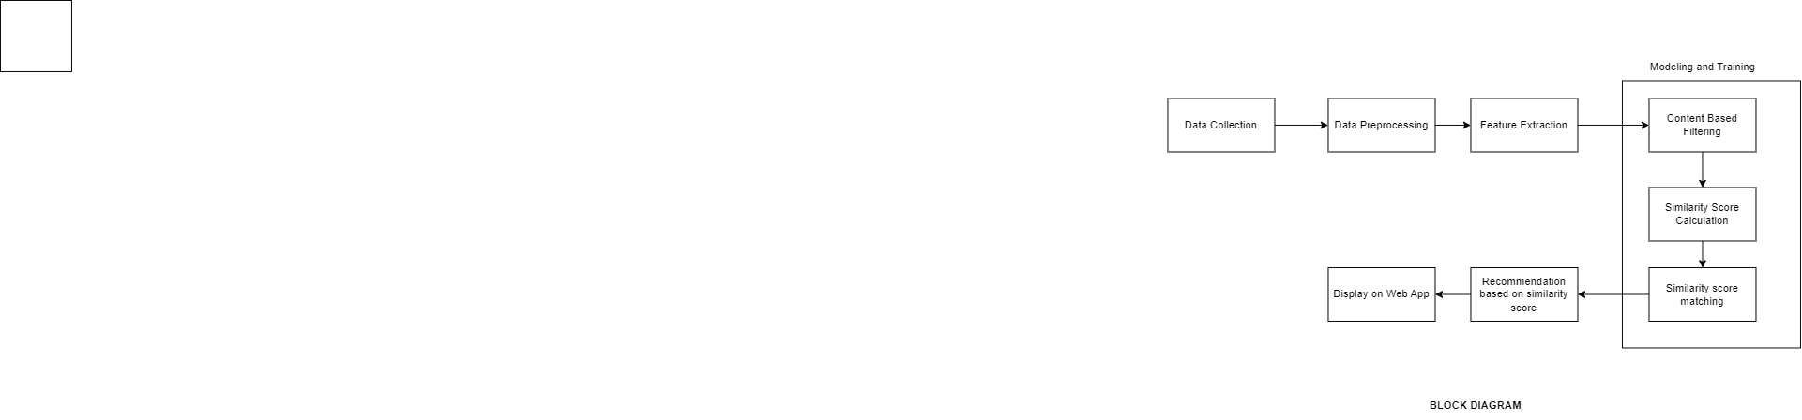

3.3 Design of the proposed system

3.3.1 Architecture/ Framework

1. Data Collection: The system should collect data from various sources such as movie databases, user ratings, and user behavior. The collected data should include movie titles, genres, and other relevant information.
2. Preprocessing: The collected data should be preprocessed to remove any unnecessary information and to normalize the data. This may involve cleaning the data, removing duplicates, and filling in missing values.
3. Feature Extraction: The relevant features such as movie genre should be extracted from the preprocessed data.
4. Cosine Similarity Calculation: The cosine similarity between movies based on their genre can be calculated using a cosine similarity algorithm. The algorithm measures the cosine angle between two vectors and gives a similarity score between 0 and 1.
5. Model Building: A model can be built based on the calculated cosine similarity scores between movies. The model can be used to generate recommendations for users based on their movie-watching behavior and preferences.
6. Recommendation Generation: Once the model is built, it can be used to generate personalized movie recommendations for users based on their movie-watching behavior and preferences.
7. User Interface: The generated recommendations should be presented to the user through a user-friendly interface, where they can browse and select recommended movies based on genre, provide feedback, and rate the recommended movies.

3.3.2 Algorithm and Process Design

Cosine similarity:

The cosine similarity algorithm is a mathematical method used to measure the similarity between two vectors. It is often used in content-based filtering approaches to recommend items to users based on their preferences.

Algorithm:

* Collect data
* Preprocess data
* Represent data as vectors
* Calculate cosine similarity
* Use cosine similarity scores for recommendations

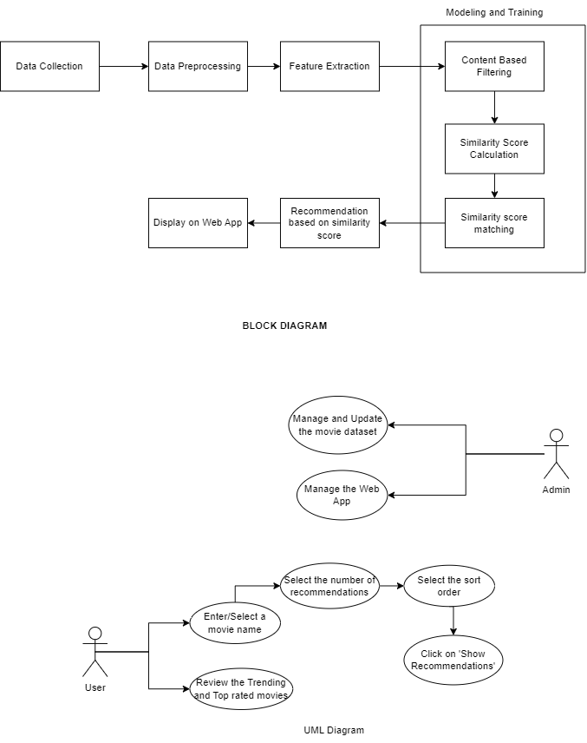

3.3.3 Details of Hardware & Software

Hardware: Laptop - processor i5, 7th generation.

Software:

# Frontend

-> Streamlit

# Backend

-> Python

# Machine Learning Algorithm.

-> Cosine similarity

# Others

-> V.S. Code (IDE)

# Version control

-> Git

-> Github

3.3.4 Experiment and Results

HOMEPAGE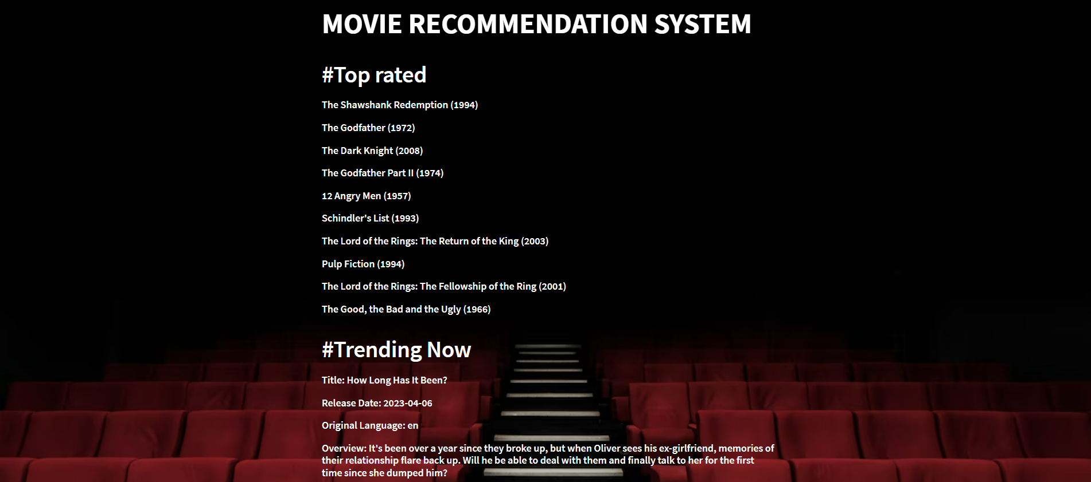

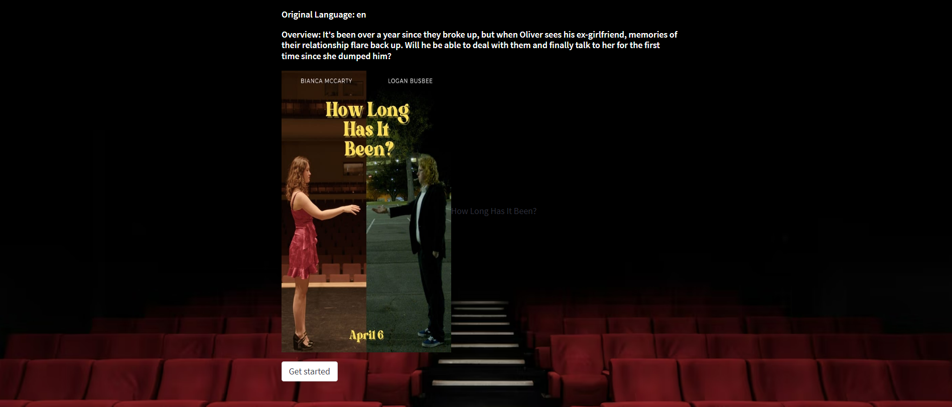

RECOMMENDATIONS PAGE

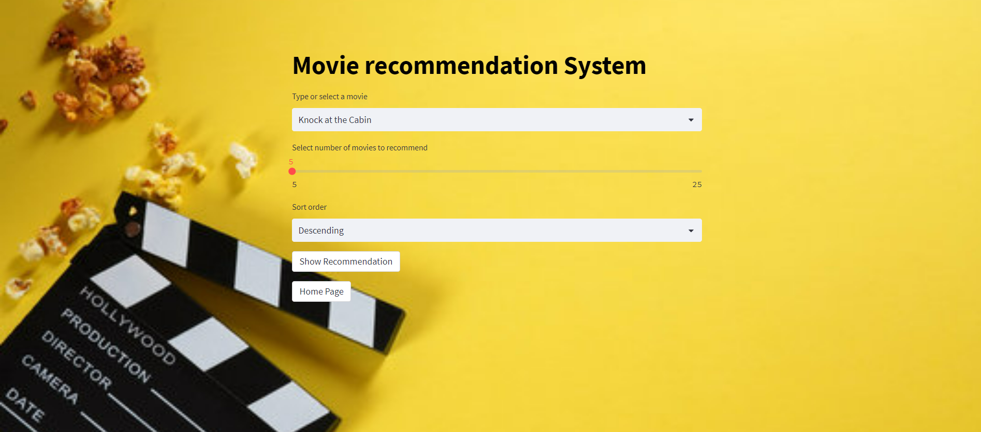

RESULTS

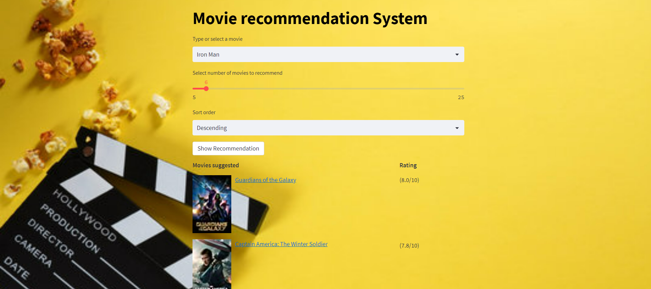



**4. Conclusion and Future Work**

In this project, we have developed a movie recommendation system using content-based filtering techniques. The system is able to suggest a list of similar movies based on the user's input of a movie title. We have used a dataset of more than 7 lakh movies. We first used the IMDbPY library to retrieve movie details and ratings from IMDb. Then we used natural language processing techniques to extract relevant features from the movie descriptions and calculate the similarity between movies. Finally, we used this similarity matrix to recommend movies based on the user's input.

It will be able to sort the results in ascending or descending order on the basis of ratings from IMDB. The movies will also have hyperlinks to its respective reviews on IMDB.

One potential improvement would be to incorporate user ratings and preferences into the recommendation algorithm. This could involve using collaborative filtering techniques, where the system learns from the user's past ratings and recommends movies that other users with similar tastes have enjoyed. Another possible direction would be to explore the use of deep learning techniques such as neural networks to extract more complex features from the movie descriptions and improve the accuracy of the similarity scores.

**5. References**

[1]<https://www.analyticsvidhya.com/blog/2020/11/create-your-own-movie-movie-recommendation-system/>

[2]<https://medium.com/web-mining-is688-spring-2021/content-based-movie-recommendation-system-72f122641eab#:~:text=Content%20Based%20Recommendation%20System%3A%20It,a%20show%20similar%20to%20it>.

[3][Movie Recommender System Project | Content Based Recommender System with Heroku Deployment](https://www.youtube.com/watch?v=1xtrIEwY_zY)

[4][Movie Recommendation Engine (Content Based Filtering) | Machine Learning | Python](https://www.youtube.com/watch?v=Dw9_BQ60ERU)

[5][Content Based Movie Recommendation System by N Pradeep](http://www.riejournal.com/article_121501_a3717e6cf19a1845e350acb9148751ee.pdf)